EXPERINMENT 2  
Meet Kansara  
Reg. no.: 220929270  
Roll no.: 54

**Exercise Question 1:** Simulate the following network scenario in CPT.

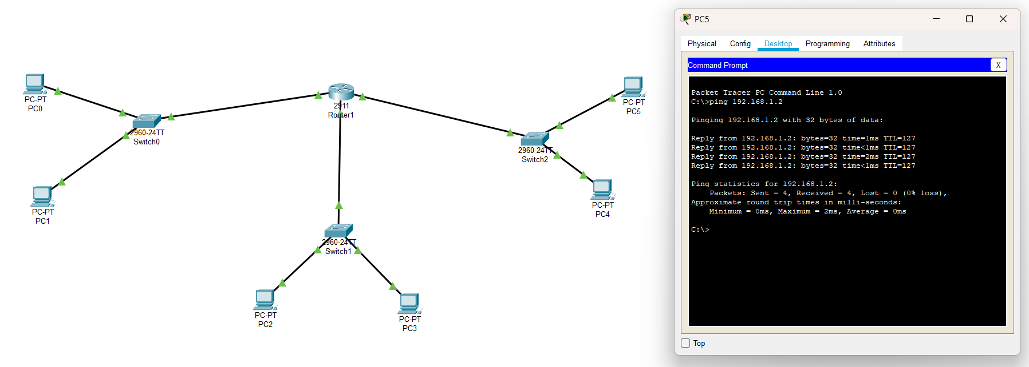

**Exercise Question 2:** Simulate the following network scenario in CPT.

